$$$NOTE: [ xxx….xxx ] means memory

//EXTERIOR - PLUFFINE FOREST - NEAR SANCTUARY//
The fire roared around Dharshna, the sound loud and terrifying. She looked at her hands in horror as flames shot out of her fingers, spreading across the snowy ground.
She pressed her hands together, but fire flared from her fingertips, igniting the ground near her feet.
Dharshna (panicking): Yen yennala idha control panna mudilaa? Yen yenaku ipdi nadakudhu?
The heat was unbearable, and the smoke stung her eyes. She coughed and stumbled back, tears streaming down her face. The more she cried, the bigger the fire grew.
Dharshna (sobbing): PLEASE FUCKING STOP!!!
“Adhigam… dhaan aa… agudhu…” she cried, panic rising. She looked around her for a moment, the trees around, the intense dark smoke forming a black and white background combining with the white colors of the snow.
Dharshna started coughing heavily. She covered her nose with one of her hands. The flames started spreading outward as well as inward. There was no place for Dharshna to escape as the yellow flames mixed with intense smoke filled the area.
Dharshna: (frightened) Yenaku idhu venammm! Na idhu kekavey illa! Dhanasree…
At that moment, she remembered Dhanasree’s words.
[ Dhanasree: Na irukan. Namma sendhu indha prechaniaiya theepom. ]
Dharshna: (pleading, to herself) Dhana…sree… yenga iruka?
Suddenly, a large burning branch fell nearby, the crash making her stun. She processed it for a moment.
Dharshna: (horrified) PAAAA!!
The fire burned brighter, and the forest was falling apart. Smoke filled the air, making it harder to breathe.
Dropping to her knees as her scream faded, she hugged her chest tightly, shrinking into herself as the flames crept closer. Appa!... …Appaaa! …Appa… she called out, her voice raw and broken, as her tears flowed through her locket.
Fire completely surrounded Dharshna leaving no room to escape. Yet, the yellow flames merely enveloped her body like a soft, coated layer just above her clothes, leaving the fabric completely undamaged
Yennala.. Yennala idha…(taking a breath) mudila… please… nillu… She squeezed her eyes shut, pressing her face into her knees, Appa… yenaku romba bayama iruku-paaaaAAA! her voice trembled in desperation.
Burning tree branches fell down, arousing a mixture of both snow and fire sparks upon impact.
Then, through the snow-fire sparks, a figure appeared. It was a man, moving quickly. His dark cloak flapped in the wind, and his glowing yellow eyes shone in the smoke.
Just as another branch fell, the man jumped forward and pulled Dharshna out of the way. They rolled in the snow together, away from the fire. Dharshna gasped, looking up at him.
He wore a dark hood that hid most of the face, showing only his blue eyes. The armor was a mix of dark and gold, with detailed designs. A white cloth wrapped around the waist.
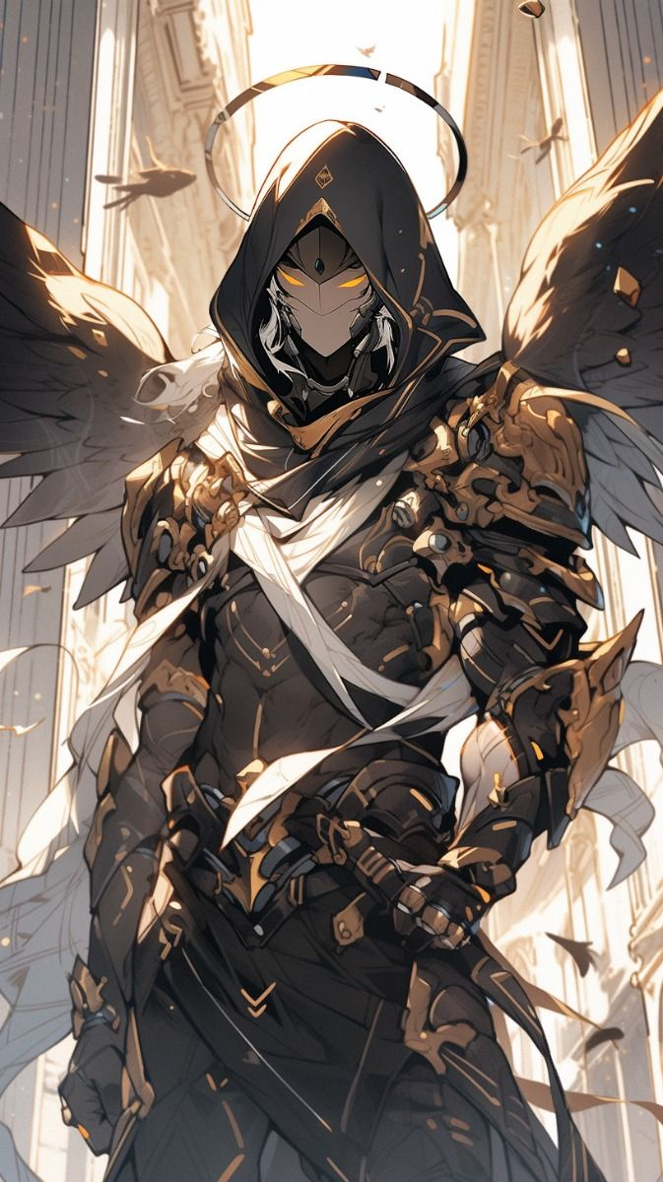
Dharshna (weakly): Tha… Thank you so much.
The man didn’t respond. He helped her stand, holding her arm gently.
He ran fiercely through the burning flames quickly, his dark armored boots throwing off snow as he ran fast.
Dharshna was shocked, she was speechless and confused.
Dharshna: (in a weak voice, looking at his mask) Yaaru… neenga?
The branches around them started falling off quickly due to the fire, and its intensity increased.
The guy: (as he charged towards the flame) Gettiya pudichikonga!
The guy came out running carrying Dharshna as two trees fell down bursting fire sizzle.
The guy slowly put down Dharshna.
The guy: Ungaluku yedhuvum aagalala?
Dharshna: (confused) Illa
The guy took his mask off.
The guy: Yen peru Kanagaraj. Unga peru?
Dharshna: (softly) Dharshna
The flames were spreading fast, but Dharshna’s eyes were fixed on Kanagaraj. She was looking at him with surprise.
The guy: (caring) Okay na romba important aana velaiya poitu irukan. Dharshna nodded her head in agreement.
//Transition//
Dharshna and Kanagaraj were standing at the top of a small cliff and looking down at those trees from a distant burn.
Kanagaraj: Indha yellow colour yellam neenga dhan create panningala?!
Dharshna initially astonished “Uhh”, then calming herself down,
Dharshna: (softly, still in shock) Aama… illa…illa…
They continued seeing the flames as there was a moment of silence between them.
Kanagaraj: (concerned) Romba bayandhuteenga pola…
Dharshna looked at Kanagaraj.
Dharshna: (her movement slow) hm.
She nodded her head slowly.
Kanagaraj: Idhu paaka romba super-ah iruku. Aana yenaku mukkiyamana vela iruku. Naan kelambikuran. Neenga paathukonga.
Kanagaraj started running.
Dharshna: Irunga. Neenga yenga irundhu vandhurukeenga?
Kanagaraj: Inga dhaan blue rose la irukan (smiling)
Kanagaraj continued to run as Dharshna stood confused. At that moment, the armored guy came walking in front of them ignoring Kanagaraj as he saw Dharshna
Dharshna was confused to see the armored guy dashing towards her. Just before she could react, the armored guy brought his sword to her forehead. But to her surprise, she fell down, starting to breathe heavily.
Kanagaraj jumped and kicked the armored guy. The sword’s handle hit Dharshna’s head but the armored guy fell down hard and started rolling down until he reached the cliff. He tried to get hold of the tip of the cliff but the armored guy couldn’t and fell down from the medium high cliff.
Kanagaraj looked down the cliff, the armored guy was lying still on the snow slowly moving his arm around.
Kanagaraj: Nallavela onnum aagala avaruku.
Dharshna was kneeling down and suffering as her arm was drooling blood.
Kanagaraj: Yaaru avaru? Ungaluku theriyuma??
She was murmuring something in her mouth.
Dharshna: va..Va…..v..
Kanagaraj: Purila?
Dharshna: (softly) Valikk..udhu!
Kanagaraj was surprised to hear that and instantly laughed out loud. “Qwehehehe”
Dharshna: (weak) Valikudhu… yen sirikura?
Kanagaraj: (calm) Unga face comedy ah irundhuchu. Oru nimisham irunga.
He removed his gloves and showed his hands to Dharshna.
Kanagaraj: Yennoda ho-ku vali vandha ipdi dhaan pannuvan. Avaluku apdiye vali parandhu poidum.
Dharshna: Yenna pandra?
Kanagaraj: Unga kai ya yen kai mela veinga!
Suddenly Dharshna was reminded of what happened with Gardener.
Dharshna: (nervous) Illa vena.Yenna pandra–
Kanagaraj dragged her hand and held tight. He caught her left palm with one of his hand and traced her nerves soothingly. He held each of her finger, pressed the tip gently and traced the nerves slowly with his fingers. Suddenly Dharshna’s nerves started to glow yellow.
Dharshna: Illa vidu!
Kanagaraj smiled at Dharshna, reassuring.
Kanagaraj: Onnumey aaugula yen tension ah irukeenga?!
Dharshna: Idhuku munnadi… oru vaati… yenna thotta oruthara apdiye burn pannitan. (words quickening) Aana na venunu pannala!
Kanagaraj’s traced till her shoulder.
Kanagaraj: Ippo yepdi iruku?
Dharshna’s breath slowly calmed down, her face getting its old glow.
Dharshna: Romba warm-ah iruku.
Dharshna slowly stood up and touched around her wounds.
Dharshna: (surprised) Yennoda pain… apdiye slow-ah maraira maari… feel agudhu.
Kanagaraj: Nammaloda RI namma moolaila dhan adhigama iruku. So anga irundhu direct ah vara nerambu yellathaiyum namma yepdi control pandradhunu therinjikita, namma vazhi ah kattu-paduthalam
Dharshna: Oh…
Dharshna closed her eyes in the soothing feeling, her face relaxed.
At that moment, Kanagaraj’s eye widened. It was the armored guy.
//Cut to//
//EXTERIOR PLUFFINE FOREST//
Dhanasree was scanning the area as she flew in the Acanus. Black smoke with yellow sparks surrounded the whole forest adding more blurriness along with the mist.
Dhanasree: (to herself) Smoke… Kandippa Dharshna va dhan irukum but onnumey theriya matingudhu…
Quickly she halted down the bird near the deer-like animal
The deer stepped closer and let out a soft noise:
Deer: Ruh-ruh...
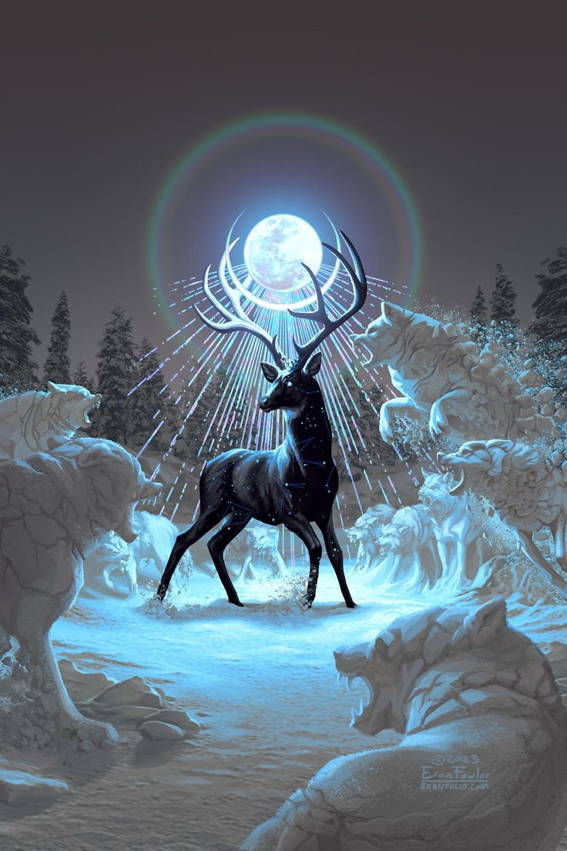
The animal stood out against the white snow. It was black with white stripes on its fur, bright green eyes, and strong, muscular legs. Its large antlers branched out beautifully, making it look powerful and graceful at the same time.
Dhanasree made up her mind. She tied her hair back into a messy bun, pushed herself up, and climbed onto the deer’s back, gripping its antlers for support.
Dhanasree: (softly mimicking) Ruh-ruh!
She patted the deer’s side. The deer neighed softly, then dug its hooves into the snow and dashed forward, moving fast and steady through the icy forest.
//Cut to//
Ragul sat under a Pluffine tree in the icy meadows, the landscape before him pristine and beautiful, but his mind was far from at ease. He leaned back, staring into the distance, lost in thought.
Ragul: (muttering to himself) Yaara irukum andha ponnu? Ava yedhanala yenna adika vandha? Oru-vela na Shreesha kuda apdi thappa nadandhuka poren-nu avaluku therinju dhaan thaduka vandhalo… Aana avaluku yepdi idhellam theriyum. Yedho idikuddhey…
As he was sightseeing, the girl with pink flowers came adorning her hair. His breath caught in his throat, and he immediately ducked behind the tree, panic rising.
Ragul: (nervously) Iva apdiye poirupa-nu la nenachan.
But the girl didn’t seem to notice. She walked past him, seemingly unaware. Just as he thought he was safe, she turned back casually, her eyes landing on him.
Pink-flowered girl: (grinning) Hey! Veliya va! Adhu needhan-nu yenaku theriyum.
Ragul froze, a bead of sweat running down his forehead. His heart raced as he tried to make sense of the situation.
Ragul: (sweating, awkward) Poachu!
The girl walked toward him, her pace slow.
Pink-flowered girl: Neeya veliya vandha onnum panna maaten. Naana unna pudichana yenna pannuvan-nu yenakey theriyadhu.
Ragul blinked, trying to make sense of her words, but his thoughts were interrupted by another voice.
Shreesha: (excitedly, appearing behind the girl ) Inga dhaan irukiya?!
Ragul’s face went pale. Shreesha had seen him, and now she was headed straight toward him. There was no escape.
Ragul slowly stood, stepping out from behind the tree, and as he did, his eyes involuntarily shifted toward the pink-flowered girl’s face. She was… attractive, but his thoughts were clouded by the tension building in his chest.
Ragul: (thinking to himself) Paaka ivalum konjo alaga dhaan irukura. Chi thappu!
He also noticed that Shreesha hasn’t worn a cloth yet.
He tried to steady his breathing as they both approached each other, the snowy backdrop swaying in the wind. Ragul’s heart raced in anticipation.
Ragul: (thinking to himself) Oru vela samadhanam-ah poita, yenaku oru pudhu ponnu friend kedaikum. Aana yellathukum ready-ah irukanum naan. Oruvela ava yenna kolla try panna-na, adhuku munnadi na avala konnudanum. Ok, yedhuva irundhalum oru kai pathukalam!
Before he could finish his thoughts, the girl slapped him hard across the face. His vision blurred as the shock of the impact sent his head spinning. His face flushed red from the sting.
Pink-flowered girl: (angrily) Ponnunga udambu-naale avlo kevalama pochula?!
Ragul’s body stiffened, and his hand shook uncontrollably as he tried to recover from the sudden strike.
Ragul: (stammering, breathless) Illa-illa-illa. Yenna vitru… theriyama-
The girl’s anger only intensified. Before Ragul could speak, she delivered a punch to his stomach. Ragul gasped for air, bending over from the blow.
Pink-flowered girl: (snarling) Ponnunga kitta ipdi dhaan nadandhukuveengala da?! Thirundhavey maatinga neenga yellam.
Ragul tried to catch his breath but was met with another slap to the face, making him stumble backward. His skin burned with the force of the hit.
Pink-flowered girl: (furiously, her fists tightening) Unna madhiri aala yellam paathaley yerichal aagudhu! Apdiye… unnoda kunja aruthu vittutu poidalam-nu thonudhu.
Shreesha was watching the chaos with laughter.
Ignoring Shreesha, she quickly kneed him in the stomach, and Ragul fell to his knees, unable to breathe properly. The pain was increasing.
With a kick to his side, Ragul was sent rolling into the snow. His head hit the ground with a sickening thud, snow splattering around him. His body was unfirm, but the pain was overwhelming. A tear slid down his cheek as he struggled to stay conscious.
Pink-flowered girl: (furious, stomping on his back) Ungaluku indha madhiri adi-odha kudukaradhu… waste-uh!
Each stomp made Ragul cry out in pain, his body curling up instinctively as he tried to shield himself. But the relentless assault didn’t stop.
Ragul: (weakly, gasping) Aahh– (gets kicked) am-! (gets kicked again) Aaaah!
Another slap hit his face, and Ragul collapsed fully into the snow, his face pressed against the cold ground. Blood mixed with the snow, and his cries became muffled as tears blurred his vision.
Ragul: (whimpering, barely conscious) A-aaa.. .. A…m..m….a
Shreesha, watching from the sidelines, was excited as her gaze fixed on the bloodied Ragul.
Shreesha: (laughing softly) Ragul nalla iruku! Thirumba apdi kathu…
Ragul lay in the snow, barely able to move, his body aching with each breath. He held his stomach with one hand while using the other to protect his head from further blows.
Ragul: (weakly, stammering) Venda… vitru yenna… Kenji kekuran.
But his cries went unheard by either of them. The girl turned to Shreesha with a cruel smile.
Pink-flowered girl: (to Shreesha, smiling) Yenga ni pannu ippo!
Shreesha’s response was quick—a kick to Ragul’s face. He barely had time to raise his hand to block it, the force of her foot still knocking him back.
Ragul: (struggling to speak, voice breaking) Vena… Shree..sha, Valikudhu
Shreesha: (with a smile on her face) Vali-na?
Ragul’s face turned hopeless.
Pink-flowered girl: (interrupting) Konjo speed ah odha, appodhan neraya red varum.
Shreesha kicked him again, but this time it was faster, with more precision. Ragul struggled as he started to tremble hard. His nose was bloodied, his body was battered, and his mind was fading.
Ragul: (shouting, desperate) Yenna…
Shreesha: (laughing as she continued) Red varudhu! Red varudhu! Inga parunga…
The pink-flowered girl’s eyes gleamed as she whispered in satisfaction.
Pink-flowered girl: (smiling cruelly) ‘Naice’.
Shreesha continued kicking, her face twisted in amusement. Ragul, in his broken state, could only whisper weakly, his voice disappearing as the world around him blurred further.
Pink-Flowered Girl: Na innonu soldran. Adhu panna innum neraya red varum.
Shreesha: Yenna pannanum adhuku?
Ragul lay on the floor, exhausted. He was struggling to breathe, clutching his stomach with one hand and softly touching his nose with the other.
Pink-Flowered Girl: Yenakku oru periya, sharp-ana blade senju tharingala?
Ragul’s heart skipped a beat. Sweat formed on his forehead as he exhaled heavily, his fear mounting.
Ragul: (thinking, frightened) Yenna kolla porala?! Ippo yenna pandradhu?!! YENNA PANNUVANNN!!!
He tried to move his body, but no matter how hard he struggled, he couldn’t.
Shreesha’s eyes glowed in determination. She focused on the snow, her hands surrounded by a soft blue aura as she molded the snow into a sharp, handle-less ice blade.
Ragul: Illa… illa… na inga irundhu thappichu ponum.
With all his strength, he let out a weak scream:
Ragul: hyaaaa..aah…hh!
But his body still refused to move. His breathing slowed, and hopelessness began to set in.
Pink-Flowered Girl: (receiving the blade from Shreesha) Thank you.
Shreesha blushed and smiled back.
She approached Ragul with slow, deliberate steps.
Ragul: (thinking) Poachu! Avlodhan… poachuu… Na… valanum-valanum-valanum-valanum!
His eyes widened as he took in the weight of the moment.
Ragul: (thinking) Yepdi-avadhu na inga irundhu thappikanum. Yennoda dream world-la yennala saaga mudiyadhu (weakly) Shreesha…
The pink-flowered girl raised the blade, her eyes filled with resolve. Slowly, she brought it closer to Ragul’s groin. His eyes widened in terror as she moved with chilling precision.
Ragul: (stammering) Shree… shree… shree…
She placed the blade at the edge of his penis and smirked.
Pink-Flowered Girl: Unna madhiri aalungaluku ipdi panna dhaan sariya varum.
Ragul froze in sheer terror, unable to scream.
//Close-up shot of Ragul’s wide, frightened eyes//
At that moment, he slowly exhaled, the sound of his breath loud in his ears. Summoning all his courage, he shouted:
Ragul: SHREESHA! Ivunga kai-kaala panila podha!
Shreesha: Red-uh?
Ragul: Ivunga odambula irundhu blue varum!
Shreesha turned to him, her face lighting up.
Shreesha: Blue-ah?! Super!
The pink-flowered girl’s expression shifted to shock. Shreesha quickly grabbed her and began dragging her into the snow.
Pink-Flowered Girl: (to Shreesha, panicked) Illa… illa idhu venam! Na first sonna madhiriye pannalam!
Shreesha: (pausing) Illa, red-ah vida blue alaga irukum.
Ragul smirked faintly despite his pain.
Ragul: (to himself, confident) Glacians yellarthoda oru key characteristic yenna-na, yellarum happiness-aala motivate aanavanga. Oru confusing aana situation vandha yosikavey matanga. Yedhu avangaluku adhiga sandhosatha kudukudho, adha dhaan seivanga. Idha naan Aadarsh Shreesha kuda veladumbodhey therinjikiten.
Pink-Flowered Girl: Yennodadhum red dhaan.
Shreesha hesitated, stopping her movements.
Ragul: (raising his voice) Shreesha… nan paathan avungaluku blue dhaan!
Shreesha nodded at Ragul with a small smile and resumed burying the girl in snow.
Suddenly, the pink-flowered girl made a small cut on her hand and showed it to Shreesha.
Pink-Flowered Girl: (smiling nervously) Inga paaru, Shreesha. Red dhaan varudhu.
Shreesha paused, her brow furrowing in confusion.
Shreesha: Aama… yen red varudhu? Ragul blue dhaan sonnan?
Pink-Flowered Girl: (freeing her legs from the snow) Ragul poi soldran!
Shreesha: Poi ah? Apdina?
Frustrated, the pink-flowered girl ignored Shreesha for a moment, then regained her sinister smile.
Pink-Flowered Girl: Avan soldradha kekadha. Na unaku neraya red–
Ragul: (desperately) AVUNGA VAILA KUTHUNA BLUE VARUM!!
Pink-Flowered Girl: Vaila kuthunalum red dhaan varum.
Shreesha stood confused.
Ragul: Shreesha, yenna namb—
The pink-flowered girl quickly drove the ice blade into Ragul’s cheek. A sickening tear followed as the blade stuck near the corner of his mouth, leaving his face torn and bloody. Ragul gasped in pain, his cries drowned by the sharp ache. Tears flowed from his eyes, mixing with the blood on his face, as his body shook from the intense hurt. His hands reached up, trying to stop the wound, but the cold, burning pain only grew stronger, pushing him closer to passing out.
Pink-flowered girl: (cunning) Ini yeppadi pesuranu paakuren. (to Shreesha) Paaru red dhaan varudhu, yenga blue varudhu?
Ragul was unconsciously rolling around, screaming in pain “Wrrrrrrr!!” without being able to voice outside.
Shreesha laughed at the weird sound Ragul made and also mocked him by doing “Wrrrrrrrr” her cheeks glowing in joy.
Pink-flowered girl (to Shreesha): Comedy ah irukula andha sound?
Shreesha: Aama!! Ragul thirumba pannu apdi!
Pink-flowered girl: Illa, avan konjo neram rest yedukatum. Romba velandutom. Neeyum poi rest yedu!
Shreesha: Illa, na poi Aadarsh oda veladuran!!
The pink-flowered girl slowly smiled gracefully at Shreesha and as soon as she ran off, she turned her face into a serious stare at Ragul who was weeping in pain.
//Abrupt Cut//

